EXPERIMENT 1
CODING
a=c(1,2,3,4,5,6)
a
print(paste("Type: ",class(a)))
b=c("Gokul","Raghul","Dhanush")
b
print(paste("Type: ",class(b))) c=c(TRUE,FALSE,TRUE,FALSE)
c
print(paste("Type: ",class(c)))
OUTPUT
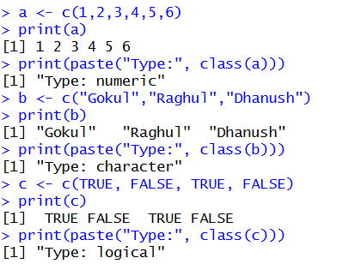

EXPERIMENT 2
CODING
a <- matrix(1:20, nrow=5, ncol=4)
print(a)
b <- matrix(1:9, nrow=3, ncol=3)
print(b)
c <- matrix(1:4, nrow=2, ncol=2)
print(c)

OUTPUT
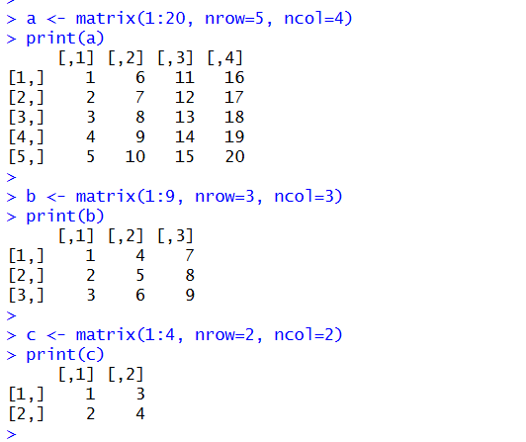

EXPERIMENT 3
CODING
a <- 1:24
arr <- array(a, dim=c(2,3,4))
print(arr)
OUTPUT
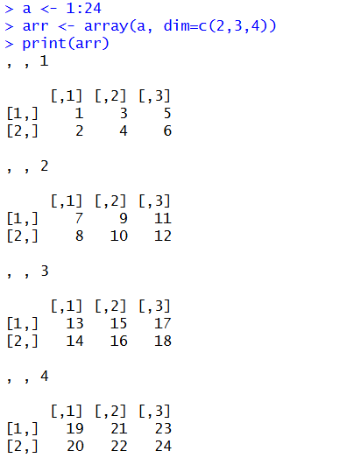

EXPERIMENT 4
CODING
a <- 1:8
b <- array(a, dim=c(2,2,2))
print(b)
print(b[2,1,2])
OUTPUT
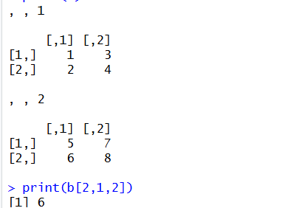

EXPERIMENT 5
CODING
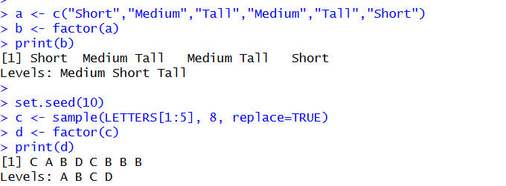

EXPERIMENT 6
CODING
a <- c(1,2,3,4)
b <- matrix(1:6, nrow=2, ncol=3)
c <- function(x) x^2
mylist <- list(Vector=a, Matrix=b, Function=c)
print(mylist)

OUTPUT
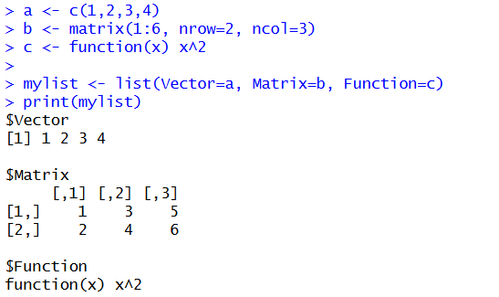

EXPERIMENT 7
CODING
n <- 12
factors <- numeric(0)
for (i in 1:n) {
if (n %% i == 0) {
factors <- base::c(factors, i)
}
}
print("Factors of the number:")
print(factors)

OUTPUT
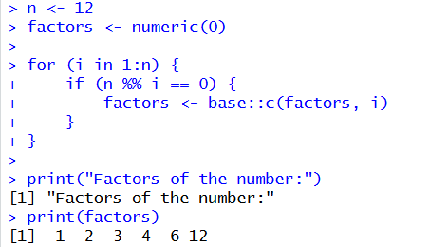

EXPERIMENT 8
CODING
set.seed(123)
x <- rnorm(100)
y <- table(round(x))
print(as.data.frame(y))
OUTPUT
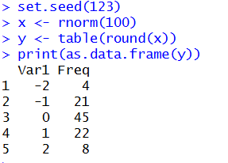

EXPERIMENT 9
CODING
plot(1, type="n",
xlim=base::c(0,10),
ylim=base::c(0,100),
xlab="x axis",
ylab="y axis")

OUTPUT
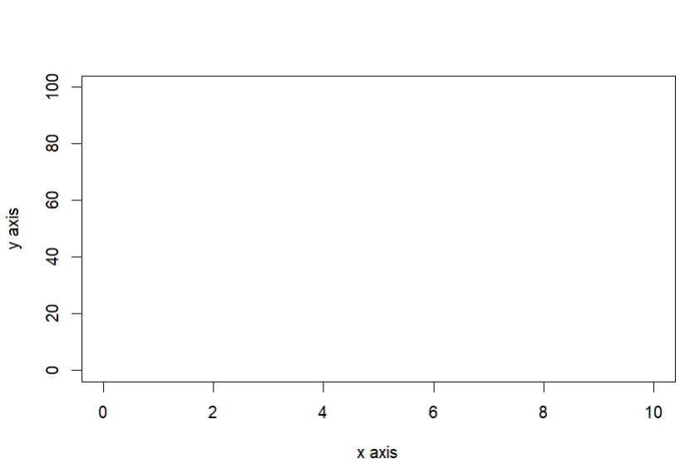

EXPERIMENT 10
CODING
x <- data.frame(
name = base::c("Anu", "Bala", "Charan", "Divya", "Esha"),
score = base::c(85, 62, 90, 75, 88),
attempts = base::c(1, 3, 2, 2, 1),
qualify = base::c("yes", "no", "yes", "no", "yes")
)
OUTPUT
